Projekt MediCOVID

Schulung von Medizinstudierenden zum unterstützenden Einsatz in der Versorgung von COVID-19-Infektionen

Stand 31.03.2020

# 



"We have here a natural disaster that is unfolding in slow motion." (Christian Drosten, virologist, Berlin Charité, 11.03.2020)

It is a fact that the World Health Organization WHO has classified the coronavirus pandemic as a "health emergency of international concern" (well over 175 countries worldwide are now affected, with more than 500,000 confirmed infections).

In order to support the highly stressed health care system in the care of severe courses of COVID-19 infections, medical students are to be trained in the diagnosis and therapy of COVID-19.

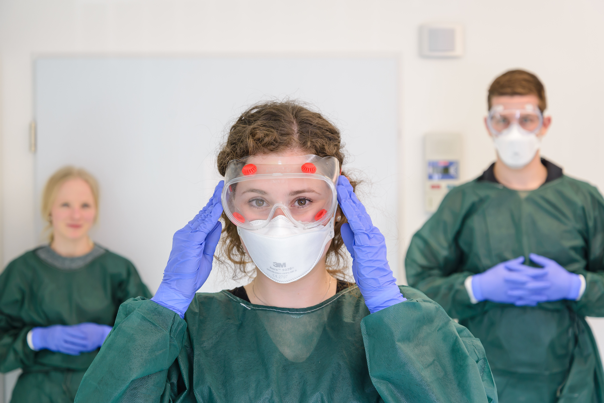

## Content

## For smartphone users: You can access the table of contents by clicking the - button (top left).

## To help you find the information you are looking for as quickly as possible, here are the quick links to the most important chapters:

* Das KONZEPT
* FACTSHEET COVID-19
* Die aktuelle Lage
* Der Infektionsweg
* Die Erkrankung
* Tutorials: “COVideos”
* Euer EINSATZ
* Selbstmanagement

# You can download the entire website as a PDF file or as an e-book by clicking the download button (, above).

# Das KONZEPT

## Ziele

## To support the highly stressed health care system in the treatment of severe courses of COVID-19 infections, medical students will be trained in the diagnosis and therapy of COVID-19.

## Zielgruppe

## The target group is you as a medical student from the clinical semesters (5th to 12th semester), who volunteer to work in the heavily burdened clinics in NRW (or even all of Germany). You should be as mobile as possible and deployed as needed.

## The aim of the training is that you can seamlessly replace each other in the care of COVID-19 patients. This applies in particular to any overload situations that may occur and also to absences due to illness (especially for COVID-19!).

## You are usually young and very often without any previous illness, so you do not belong to one of the risk groups. In the further course of the pandemic and with an expected infection rate of about 60-70 % of the total population, all persons must expect to be infected even without working in the health care system. Here you simply have a significantly lower risk of experiencing serious symptoms of illness or a life-threatening situation than older people (which of course includes older medical colleagues).

## After a survived infection you are (according to all that is known so far) immune to the disease for 2-3 years. This would of course be ideal for use on patients with COVID-19.

## Lernziele

## What should you be able to do after the training?

## We want to train you especially for the needs in the admission situation of COVID-19 patients.

## Similar to Physician Assistants, you should relieve the doctors on site and prepare medical decisions as well as possible.

## Ideally, you should exclusively care for COVID-19 patients.

## For this purpose you should master the following activities:

## - consistent application and implementation of basic hygiene, especially hand hygiene with and without disinfectants

## - correct use of personal protective equipment (PPE): protective gown, disposable gloves, respirator (FFP2 or FFP3) and safety glasses

## - controlled putting on (especially tight fit of the respirator)

## - correct filing (with multiple hand disinfection)

## - Anamnesis and physical examination of COVID-19 patients with correct documentation

## - depending on necessity, taking of blood or blood cultures

## - Report of the findings to the responsible physicians, preparation of the decision for further treatment of COVID-19 patients

## - Update and, if necessary, adjustment of all the above steps in line with developments in the supply situation

## Organisation der Schulung

### Umfang der Schulung

### The training is designed for a one-day seminar or internship with about 8-10 hours of theoretical and practical instruction.

### Subject to the distance rules, 12 to 72 students per day (after digitalisation of the theoretical contents) can participate in the training.

### The theoretical contents are converted into digital formats after a few passes in order to keep the contact times among each other and with the medical lecturers as short as possible with regard to transmission of SARS-CoV-2.

### Ort der Schulung

### The courses take place in the Study Hospital of the Medical Faculty of Münster.

### This place is well known to you as Münster students, you can find your way around there easily. Thus, possible transmissions of SARS-CoV-2 can be prevented during the courses.

### The team of the Studienhospital has a lot of experience in organizing trainings for you medical students.

### Start der Schulung

### The info for the respective start of the event can be found here:

### Download Participant Info_Training_MediCOVID_20200325.pdf

### It is important to us that we do not spread the coronavirus from here to the hospitals. We want to avoid this at all costs, so we have devised a special procedure. Please have a look at the "COVideo" so that you know the procedure well!

### In preparation for the deployment and preferably also for the training, you should work through all numbered chapters of www.medicovid.de.

### Betreuung der Schulung

### The concrete course of the training is organised by the team of the Studienhospital and is constantly adapted to the current situation.

### Lecturers are initially recruited from the clinical sector and are gradually replaced by peer-teaching (i.e. trained students).

### Nachbetreuung

### The need for a follow-up care of you arises for possible situations of overwork (both physical and psychological) and also sick leave (especially for COVID-19).

### Here we will set up a corresponding "hotline" with professional staff:

### For 24 hours 7 days a week a ZOOM Room 24/7 or chat room will be at your disposal during your assignment. All you need to do is download the ZOOM software from your devices. The chat room can be accessed under ID 2518353110.

### There we also visit you from time to time, you can exchange and report among yourselves and make handovers. If necessary, supervisors or psychologists will join the chat.

### Koordination mit den anfordernden Kliniken

## To this end, a central contact point / hotline will be set up to prioritise the corresponding requests.

## The hospitals can send a request for a request to studierende.covid@uni-muenster.de.

## In case of queries, hospitals can contact the team of the Institute for Training and Academic Affairs (IfAS) on the following telephone hotline: 0251 / 83 - 589 45

## For you students, the corresponding information is described under Your Assignment.

## Inhalte der Schulung

# The contents of the training are strictly prioritized with regard to the management of COVID-19 disease and its complications.

# The following topics will be covered for you:

# Theory:

# - COVID-19: current situation report

# - COVID-19: Background and knowledge regarding diagnostics and therapy

# - COVID-19: Complications - background and concrete options for action [in development ...]

# - COVID-19: Care - self-protection and treatment

# Practice:

# - Self and external protection: Hygienic behaviour in the supply of COVID-19

# A current draft of the teaching concept with a time schedule can be found here:

# Download schedule_training_MediCOVID_20200324.pdf

# FACTSHEET COVID-19

# Summary according to [1]:

# - The official name of the novel coronavirus is "SARS-CoV-2". The corresponding clinical picture and the disease are called "COVID-19".

# - Detection is done from a deep throat swab by PCR.

# - This is a droplet infection.

# - When caring for patients, it is essential to ensure that basic hygiene (including hand hygiene) is consistently applied and that personal protective equipment (PPE: protective gown, disposable gloves, tight-fitting respiratory mask [FFP2 or FFP3] and protective goggles) is used correctly. The correct use of PPE is important, this includes controlled donning (especially tight fit of the mask - easy) and correct removal (with multiple hand infections - difficult!).

# - The disease manifests itself as an infection of the respiratory tract with the leading symptoms of fever and cough.

# - In 81% of patients the course is mild, in 14% severe and 5% of patients are critically ill [2].

# - Admission to the intensive care unit is usually accompanied by dyspnoea with increased respiratory frequency (>30/min), with hypoxaemia being the main symptom. The time between the onset of symptoms and admission to the intensive care unit is about 10 days [3].

# - The aim of the therapy is to ensure adequate oxygenation, SpO2 ≥90 % is recommended [4].

# Die aktuelle Lage

## "We are in a situation that is extraordinary, in every respect [...]" (Angela Merkel, Federal Chancellor, 12.03.2020)

## To help you grasp the significance of the coronavirus pandemic and have relevant arguments for yourself or others, here is a list of relevant points:

## Das Virus

The virus responsible for the current coronavirus epidemic is called SARS-CoV-2, which according to current knowledge causes the disease COVID-19 (Corona virus disease 2019).

The currently used term "coronavirus" is actually too general, since there are many different coronaviruses, which also have different pathogenicity. But what is important about the name is that it expresses the special form of the virus (see figure 1): if you look closely you can see that small spikes protrude outwards from the envelope of the virus and thus form a kind of wreath (lat: corona).

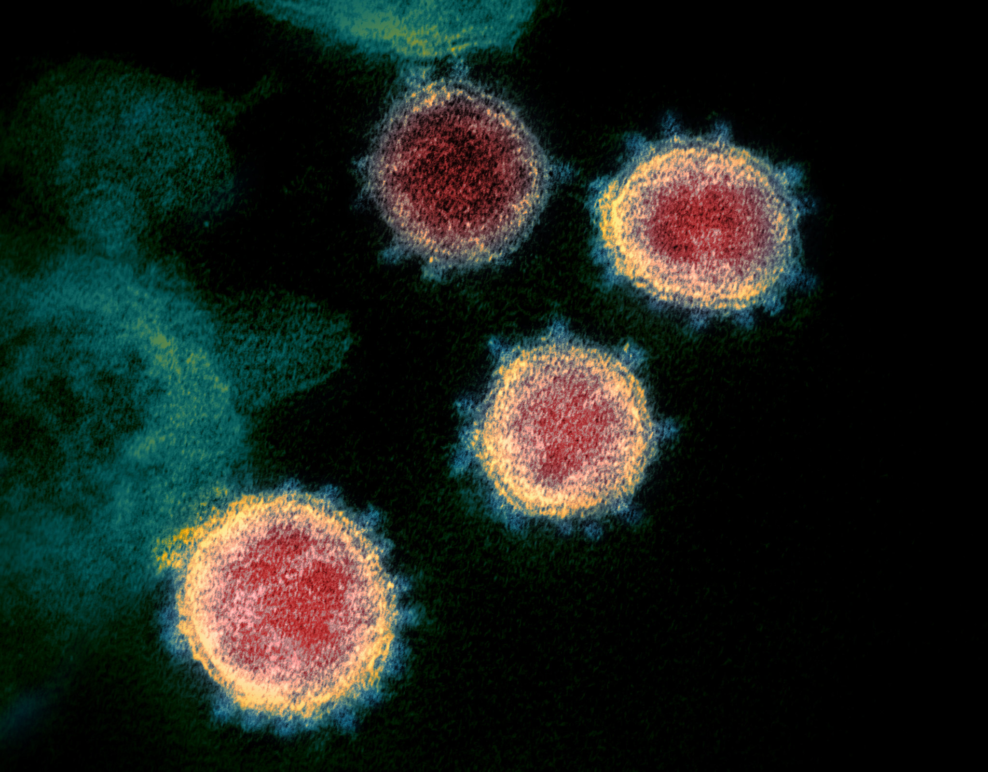

Figure 1: Elektronenmikroskopische Darstellung des Coronavirus **SARS-CoV-2**; by NIAID Rocky Mountain Laboratories (RML), U.S. NIH - <https://www.niaid.nih.gov/news-events/novel-coronavirus-sarscov2-images>, Public Domain, <https://commons.wikimedia.org/w/index.php?curid=87089605>

## Verbreitung des Virus

## Since 20 January 2020 it has become increasingly clear that the virus is spreading from person to person [5] and it is now known that the main transmission route is via droplets - i.e. sneezing and coughing. In a typical human-to-human infection, the distance is up to two metres.

## However, virus particles have also been detected in the stool of infected patients [6]. Whether this means that the virus can also be spread via the stool has not yet been conclusively clarified (see the website of the Federal Centre for Health Education https://www.infektionsschutz.de/coronavirus-sars-cov-2.html).

## Theoretically (!) it is possible to become infected in people who have already been infected themselves, but are not yet or not yet ill. However, this has not yet been proven [7] and the World Health Organization currently assumes that this transmission route probably does not play a major role [8].

## We are dealing with a so-called "dynamic outbreak". Due to the lack of vaccination options, the virus spreads unchecked and the aim is to slow down this spread. This means that almost everyone - including you (!) - will get this infection. The aim is to reduce the number of serious illnesses per week so that the hospitals can cope with them.

## The decisive and currently also most important way of transmission is therefore the droplet infection, i.e. by coughing, sneezing and shaking hands. As a consequence, "wherever possible, social contacts should be avoided [...]" (Angela Merkel).

## Accordingly, the consistent application and implementation of basic hygiene, especially hand hygiene with and without disinfectants, is important for you. In addition, the correct use of personal protective equipment [PPE; protective gown, disposable gloves, respiratory mask (FFP2 or FFP3) and safety goggles], in particular the controlled putting on and taking off of the protective goggles (with multiple hand disinfection).

## Die Lage bei uns

Certainly the current conditions in Italy, as a European neighbour and popular holiday destination, affect us particularly. Accordingly, you will find in figure 2 the comparison of the illness figures until yesterday.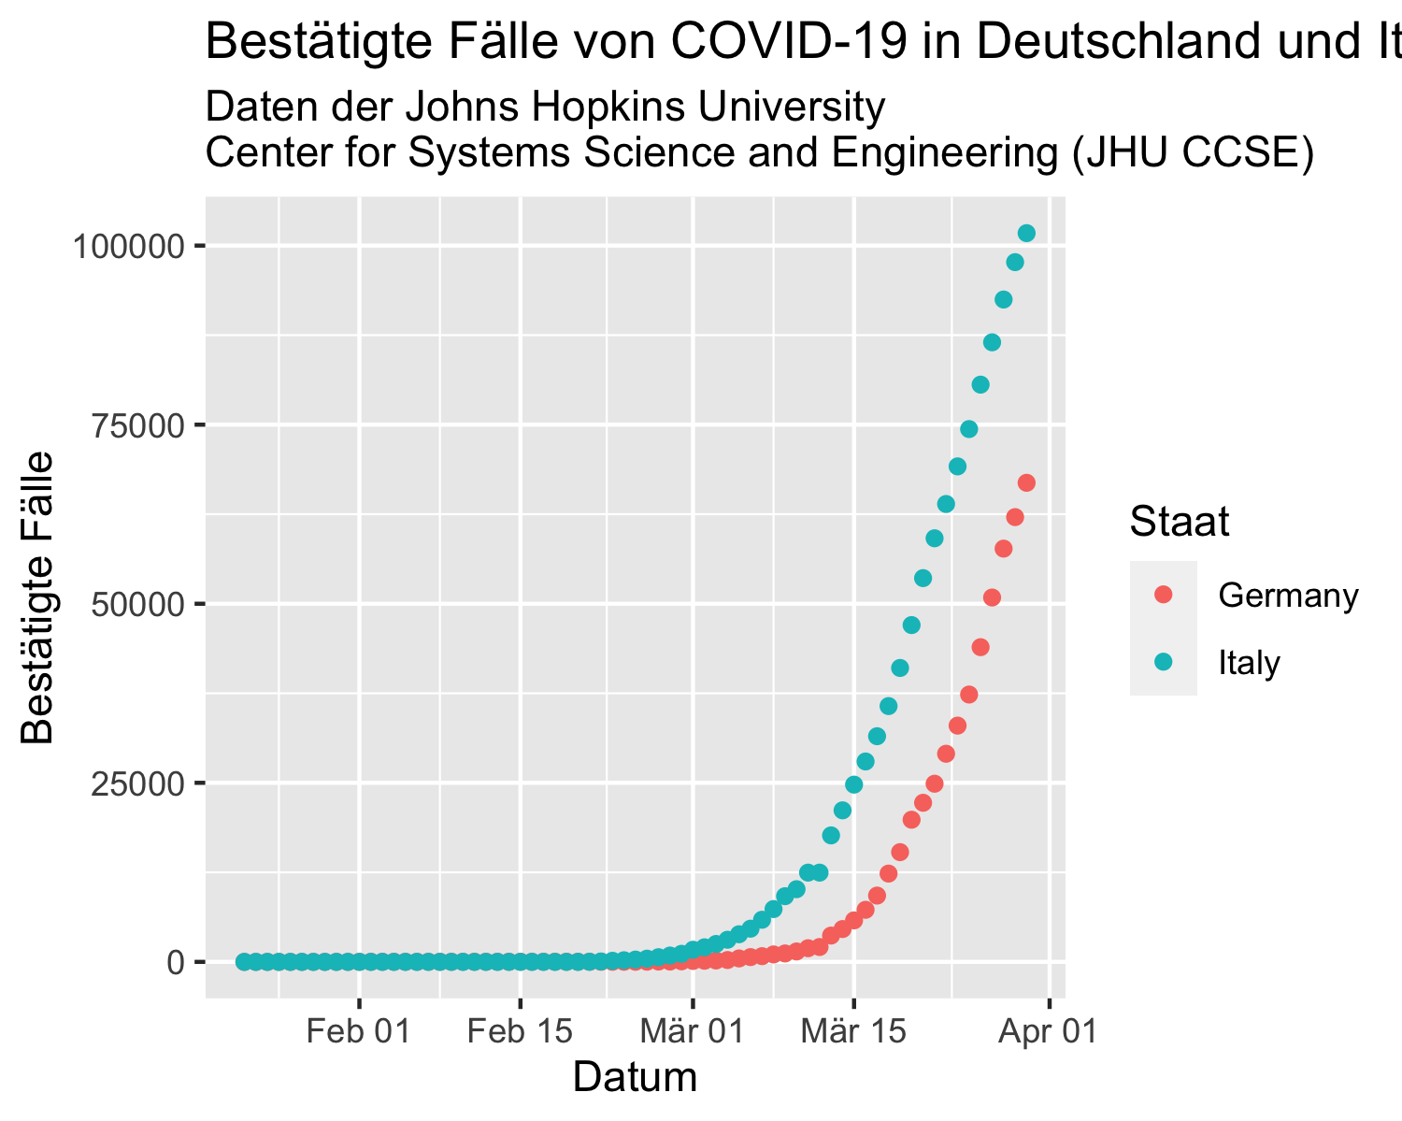

Figure 2: Bestätigte Fälle von COVID-19 in Deutschland und Italien

However, since Italy has fewer inhabitants than Germany, it is of course more important to consider the number of illnesses in relation to the number of inhabitants. For this reason, Figure 3 below shows the number of illnesses per thousand inhabitants. In order to be able to interpret these figures better, we have added the relevant government measures as horizontal lines.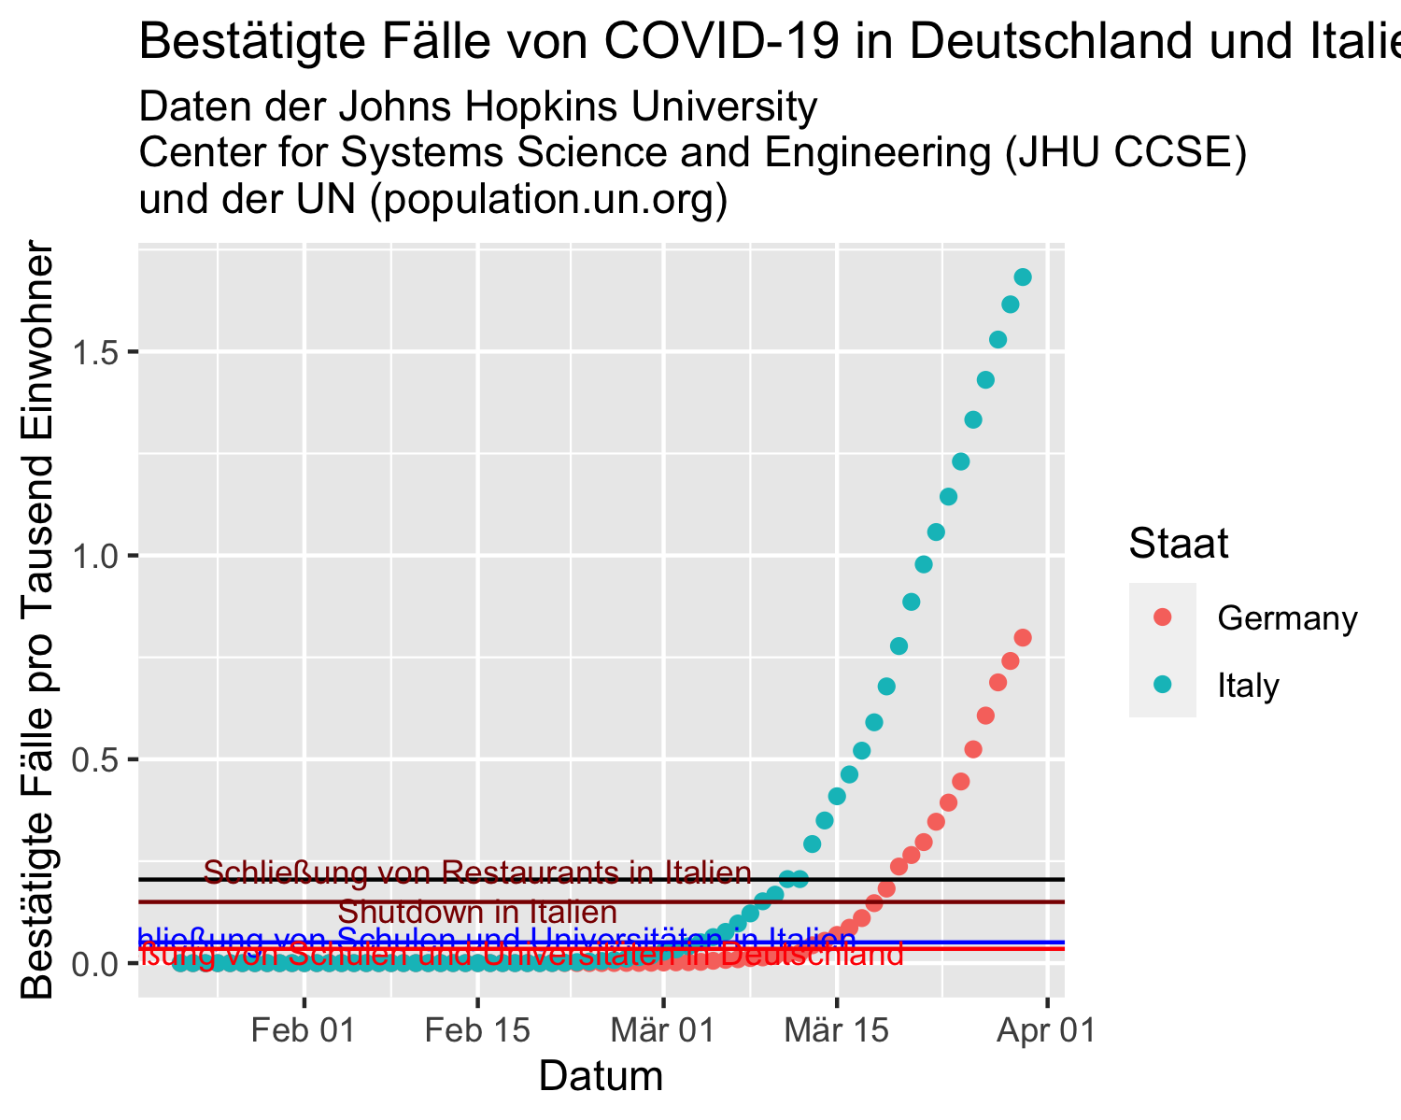

Figure 3: Bestätigte Fälle von COVID-19 in Deutschland und Italien und die entsprechenden Maßnahmen

## It makes sense, above a certain level of spread of a disease, to no longer take the number of infected persons (which is subject to a high degree of uncertainty anyway), but the number of deaths as an indicator of the burden on the health care system. Here too, it is wise to consider this in relation to the number of inhabitants.

## Please be prepared for the fact that from an as yet undetermined point in time the number of deaths will become the focus of attention. This makes perfect medical sense, but of course it does something to the people. It is important that you do not see this as a failure of the health system.

## Zu erwartende Todeszahlen

It is currently estimated that about 60-70% of the population could be infected by the virus within the next two years. The case-to-case mortality rate of a proven COVID-19 infection is currently estimated at about 0.7% if the health care system is intact.

Here, however, we are much more interested in the so-called lethality (the "lethality", describes the number of dead cases as a proportion of the number of sick cases) of COVID-19. This includes the number of sick cases that have not been tested. It is assumed that the number of sick cases is underestimated by a factor of 4.5-11.1 (see RKI). A factor of 7 would result in a lethality rate of about 0.1%.

Under the current conditions, this means that we can expect an additional 50,000 deaths in Germany in the course of this pandemic. For the European Union (approx. 450 million inhabitants) this would mean approx. 270,000 additional deaths.

These are more deaths than the two atomic bombs dropped on Hiroshima and Nagasaki at the end of World War II (approx. 129,000 to 226,000 victims, source: WIKIPEDIA)!

Here is the current status (for better comparability in comparison with Italy)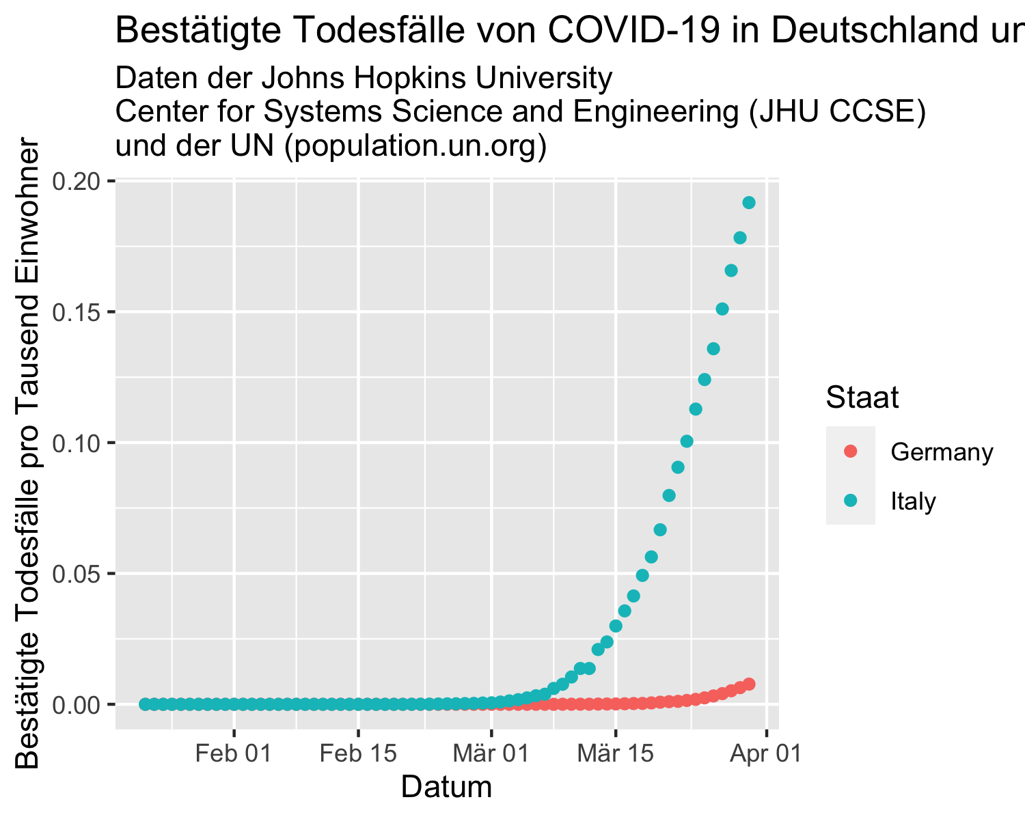

Figure 4: Bestätigte Fälle von COVID-19 in Deutschland

## ABER …

# The SARS-CoV-2 virus is NOT EBOLA!

# What I mean to say is that, despite the above figures, the virus is still - relatively speaking (!) - harmless.

# Accordingly, it gives us the opportunity to learn many things that would be necessary in case of an outbreak of a much more dangerous epidemic.

# Der Infektionsweg

# Since 20 January 2020 it has become increasingly clear that the virus is spreading from person to person [5] and it is now known that the main transmission route is via droplets - i.e. sneezing and coughing. In a typical human-to-human infection, the distance is up to two metres.

# However, virus particles have also been detected in the stool of infected patients [6]. Whether this means that the virus can also be spread via the stool has not yet been conclusively clarified (see the website of the Federal Centre for Health Education https://www.infektionsschutz.de/coronavirus-sars-cov-2.html).

# Theoretically (!) it is possible to become infected in people who have already been infected themselves, but are not yet or not yet ill. However, this has not yet been proven [7] and the World Health Organization currently assumes that this transmission route probably does not play a major role [8].

# If you have had contact with people who are sick and the virus has spread to you, it can take up to 14 days before you get COVID-19. In most cases, however, the first symptoms appear within 3-6 days [5]. Most patients fall ill after 5 days [9].

# Die Erkrankung

For one person, the disease typically begins with fever and possibly coughing [2]. The further course of the disease is divided into mild, severe and critical, with the mild course being by far the most common (see Figure 5).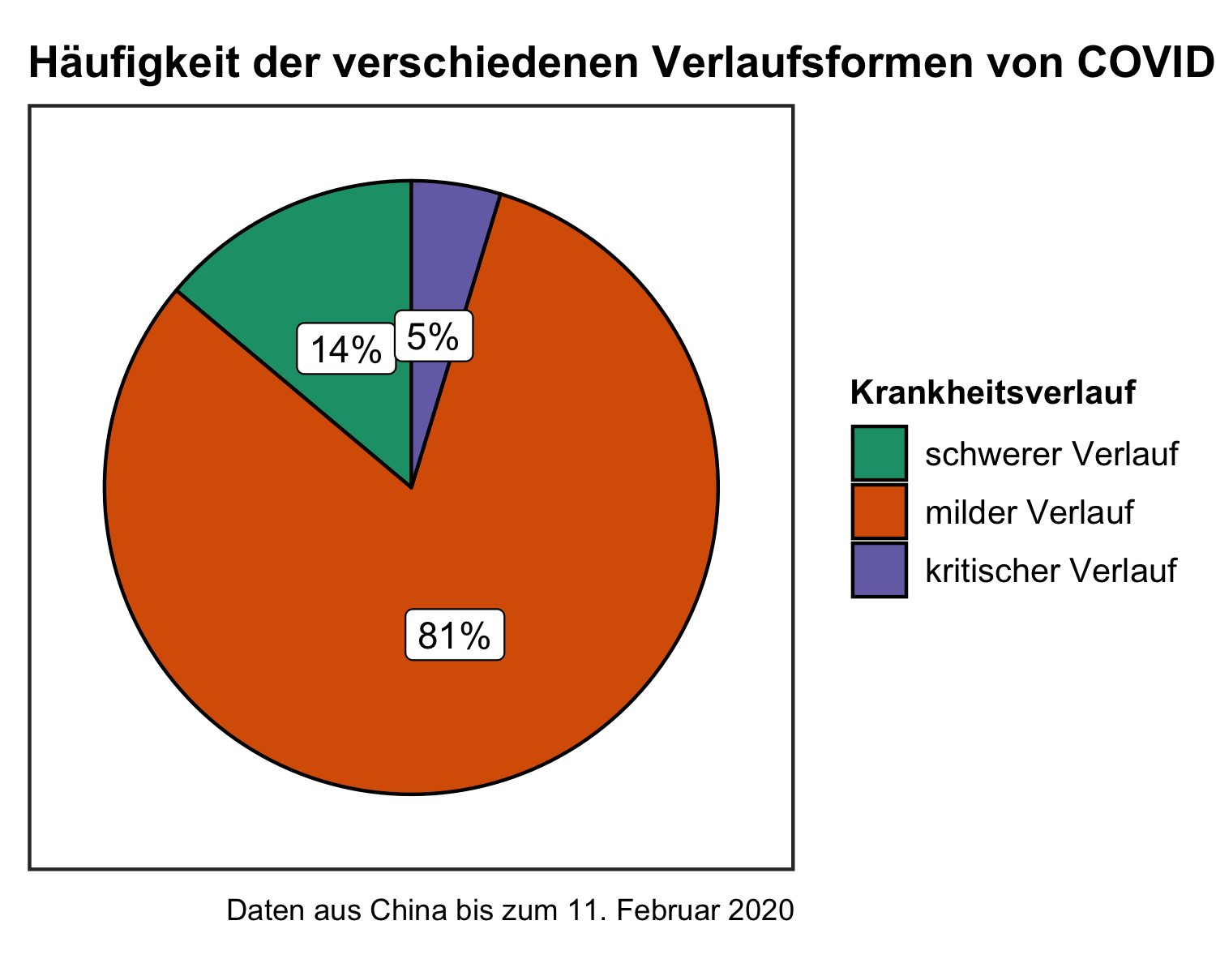

Figure 5: Häufigkeit der verschiedenen Verlaufsformen von COVID-19

## 81 out of 100 patients have a mild course of the disease. This means that they have no signs of pneumonia or mild symptoms, if any.

## In contrast, 14 out of 100 patients have a severe course of the disease, which means that they mainly have problems breathing. The patients have shortness of breath, breathe more than 30 times a minute and have less oxygen in their blood due to the shortness of breath (this is measured by the health service in the hospital or ambulance).

## 5 out of 100 patients become critically ill. This means that breathing fails and/or other vital organs (kidney, liver, ...) fail.

## Diagnose

### Klinische Symptomatik

The disease manifests itself as an infection of the respiratory tract with the leading symptoms of fever and cough. Other symptoms are significantly less frequent and unspecific or represent a possible complication of the disease (shortness of breath).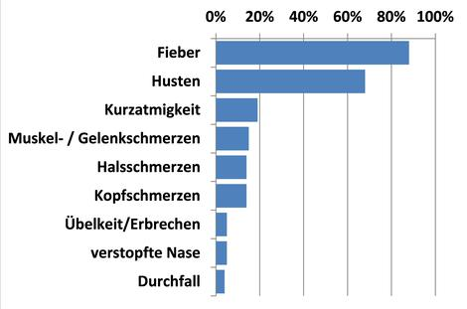

Figure 6: Erregersteckbrief des Robert-Koch-Instituts, www.rki.de

### COVID-19 is similar to many other repiratory diseases and can also be fever-free. It is therefore primarily a febrile cold, if there are no complications.

### About 80% of the patients confirmed in the laboratory have a mild to moderate disease, which also includes cases without and with pneumonia.

### One in five patients (19%) experience clinical worsening with the development of dyspnoea (shortness of breath) and/or hypoxaemia. These typically occur about 7-10 days after the onset of symptoms. Strictly speaking, 13.8% have a severe disease (dyspnea, respiratory rate ≥30/minute, blood oxygen saturation ≤93 %, PaO2/FiO2 ratio <300, and/or lung infiltrates >50 % of the lung field within 24-48 hours) and 6.1% are critical (respiratory failure, septic shock and/or multiorgan failure) [10].

### Risikopatienten

### General predictors for a more severe course are:

### - age (>50 years)

### - male sex

### - Pre-existing conditions

### Speak for a deterioration in the clinic:

### - Dyspnea and persistence of fever

### - also a pronounced lymphopenia and an increase in LDH and troponin

### [The fever is often barely controlled by antipyretics.]

### Klinische Klassifikation

## - mild: mild symptoms

## - moderate: slight pneumonia

## - severe: severe pneumonia

## - fever or suspected respiratory infection and

## - either respiratory frequency > 30/min, severe shortness of breath or SpO2 <90% in room air

## - critical (ARDS, sepsis, septic shock)

## Behandlung

### According to the WHO, the recovery time seems to be about two weeks for mild infections and three to six weeks for severe diseases.

### As with many viral diseases, the therapy is still purely symptomatic.

### The therapy depends on the severity of the disease and on supportive measures. Patients with a severe and critical course of the disease should be subjected to intensive medical monitoring and care at an early stage.

### General measures for inpatient care (according to [11]):

### - Restrictive fluid therapy (as this can worsen oxygenation), nutritional optimisation

### - Close-meshed monitoring of vital parameters to detect severe progressions at an early stage

### - Consideration of comorbidities (necessary long-term therapies, therapy restrictions?)

### - Oxygen administration (nasal, mask, if necessary high-flow), according to need, target SpO2 > 90% in non-pregnant adults, > 92 - 95% in pregnant women (WHO guidelines) CAVE: Aerosol formation at high oxygen flow

### - Regular monitoring of inflammation parameters, kidney function, liver values, coagulation. Further imaging depending on the clinical course.

### - If necessary, acceptance of several blood cultures (each aerobic & anaerobic)

### Gefährdung

Europe now (as of 14 March 2020) has more new confirmed SARS-CoV-2 cases every day than at the peak of the epidemic in China. The Robert Koch Institute (RKI) upgraded the risk for Germany to high on 17.03.2020.

In an article published on February 24, 2020 in the American Medical Journal (JAMA, [2], data from [12]), the extent of the risk to humans from COVID-19 was described for the first time using large case numbers.

A total of 44,672 confirmed cases (up to 11 February 2020) were reported and deaths counted.

These are as follows:

Gefährdung bei Erkrankung an COVID-19

in China bis zum 11. Februar 2020

Alter

Bestätigte Fälle

Tod

Todesanteil

0 bis 9 Jahre

416

0

0 %

10 bis 19 Jahre

549

1

0,2 %

20 bis 29 Jahre

3619

7

0,2 %

30 bis 39 Jahre

7600

18

0,2 %

40 bis 49 Jahre

8571

38

0,4 %

50 bis 59 Jahre

10008

130

1,3 %

60 bis 69 Jahre

8583

309

3,6 %

70 bis 79 Jahre

3918

312

8,0 %

über 80 Jahre

1408

208

14,8 %

Quelle: The Epidemiological Characteristics of an Outbreak of 2019 Novel Coronavirus Diseases (COVID-19) — China, 2020; weekly.chinacdc.cn

# Over 80% of the cases were mild (36,160 cases), one in seven cases severe (6,168 cases) and one in twenty critical (2,087 cases).

# A total of 2.3% of the patients (1,023 people) died. For men the mortality rate was 2.8% (653 people), while for women it was 1.7% (370 people). Most fatal cases occurred in patients with advanced age or underlying underlying medical conditions (such as diabetes).

# For example, a maximum of every 250th patient dies from the ill patients until the age of 50. From the age of 51, the mortality rate increases from every 77th to every 7th patient (for ill patients over 80 years of age).

# In summary, it can be said that older people over 60 (death in every 28th patient), men and people with pre-existing conditions are particularly at risk according to current knowledge.

# COVideos

## Einleitung

Our student tutors have created some tutorials that should serve as a guide for you:[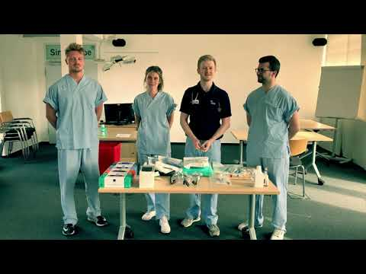](http://www.youtube.com/watch?v=mesq1GbHjCI)

## Die Schulung

To prepare for the training, you should know these first steps for the practical course of the training:[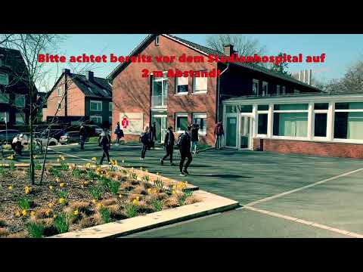](http://www.youtube.com/watch?v=HvkV_4oqseo)

Here also the introduction for the course as video:[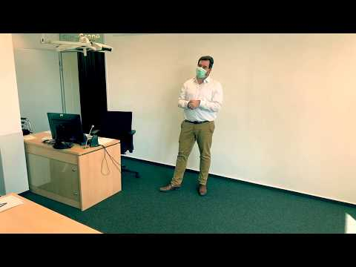](http://www.youtube.com/watch?v=459IU1MfwVQ)

## For the practical handling of COVID-19 patients you should master the following activities:

## Basishygiene

## Consistent application and implementation of basic hygiene, especially ...

## - ... of hand hygiene with disinfectant: hand disinfection

[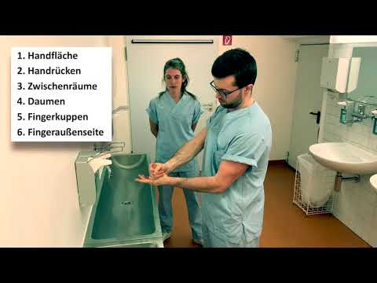](http://www.youtube.com/watch?v=_kks26L1UlA)

- ... and hand hygiene without disinfectants: washing hands[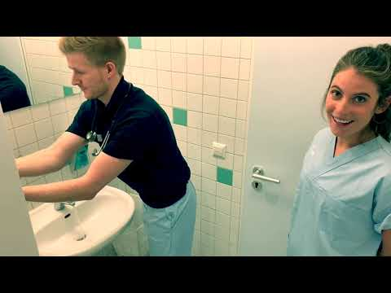](http://www.youtube.com/watch?v=yTKlnBNzXrQ)

## Persönliche Schutzausrüstung (PSA)

## The correct use of personal protective equipment (PPE): protective gown, disposable gloves, respirator (FFP2 or FFP3) and safety goggles

## - Controlled fitting of PPE (including initial tight fit of the respiratory mask)

[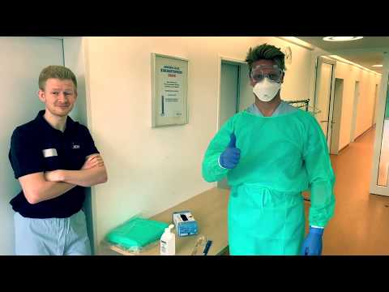](http://www.youtube.com/watch?v=xPxe-jin4m0)

**- quick application of the PSA**[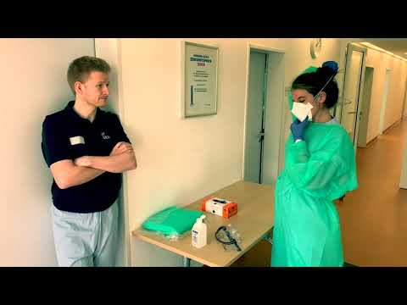](http://www.youtube.com/watch?v=LEzJ7TUlIJ0)

**- correct removal of the PPE (with multiple hand disinfection)**[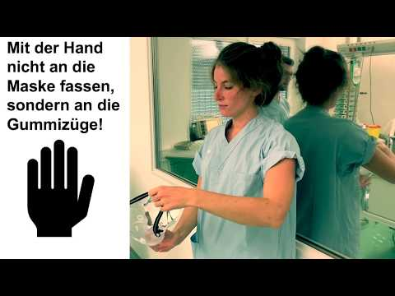](http://www.youtube.com/watch?v=AmLcAMKmblU)

## - Anamnesis and physical examination of COVID-19 patients with correct documentation [under construction ...]

## Abstrich auf SARS-CoV-2

- Testing for COVID-19: the smear[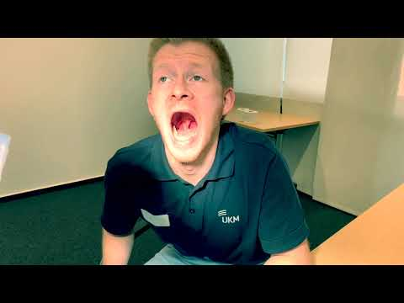](http://www.youtube.com/watch?v=L8_IWvl4F5o)

## Periphere Verweilkanüle

- with good preparation: placement of a peripheral indwelling cannula (PVC): the preparation[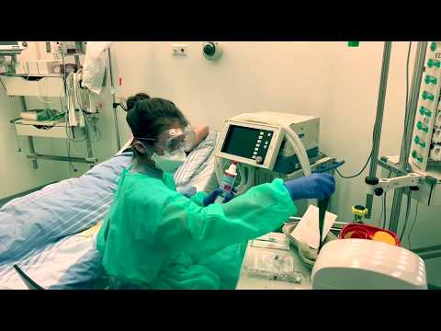](http://www.youtube.com/watch?v=j1DkbD4cFtw)

- according to necessity: placement of a peripheral indwelling cannula (PVC): the placement[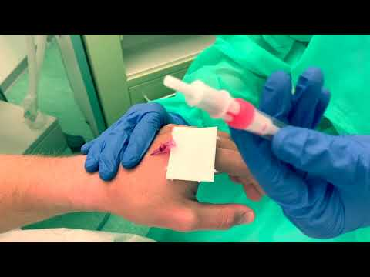](http://www.youtube.com/watch?v=d1EGCACoy34)

- according to necessity: prepare and connect infusion[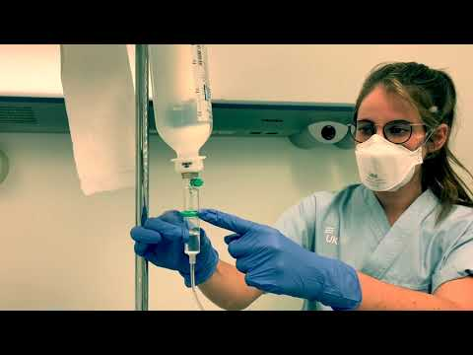](http://www.youtube.com/watch?v=0q6GGB-AfPk)

## Blutkulturen

## - depending on necessity: taking blood cultures

## Monitoring

- Preparation of the decision for further care of COVID-19 patients: e.g. monitoring[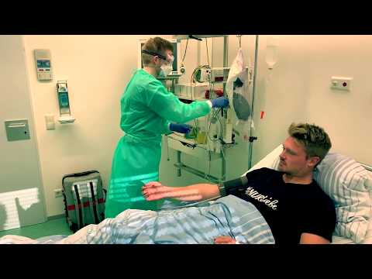](http://www.youtube.com/watch?v=ZPJh-zeqiNI))

- Preparation of the decision for further treatment of COVID-19 patients: e.g. qSOFA-Score[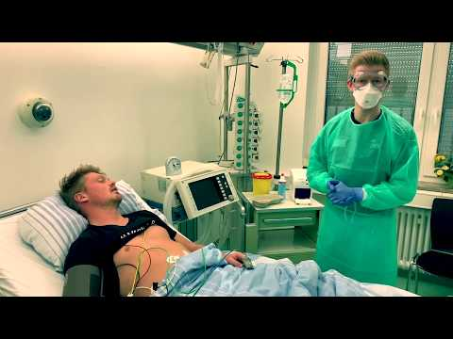](http://www.youtube.com/watch?v=77ibWEHQVFY))

## Selbstmanagement-Übungen

**- Self-management exercises**[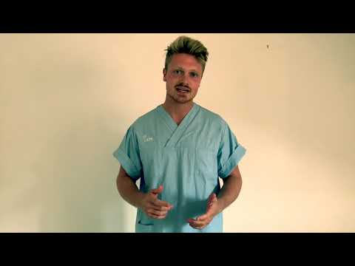](http://www.youtube.com/watch?v=mW41SPVnjY8)

# - Update and possibly adjustment of all the above steps after the supply situation develops [under construction ...]

# Euer EINSATZ

After we have trained you on the needs in the admission situation of COVID-19 patients, the assignment in a (teaching) hospital follows.

You will be assigned by us as a MediCOVID team of three students to a hospital that has previously committed itself to provide you with accommodation and meals.

As a team of three you are to fill a position in the care of COVID-19 patients and can assign yourself (as a team) accordingly. The previous teams did this e.g. in 8-hour shifts (with additional times for handing over).

Similar to Physician Assistants, you are supposed to relieve the doctors on site and also protect their urgently needed expertise through your direct involvement with the patient.

For all those who are already trained and would like to choose your place of work, the following link will be activated: https://medicampus.uni-muenster.de/mstud-verfueg-lhk01.html from 30.03.2020, 15.30 hrs.

In general, your deployment is scheduled for about 10 days. If something special happens (e.g. that you get sick, e.g. by getting infected with SARS-CoV-2, or if an overload occurs) you will contact us and we will release you by another team.

We are happy to advise you! At any time you can contact us on the well-known hotline: 0251-83-58915; or leave a message at eschoene@uni-muenster.de.

For 24 hours 7 days a week a ZOOM Room 24/7 or chat room is available during your assignment. All you need to do is download the ZOOM software from your devices. The chat room can be accessed under ID 2518353110.

There we also visit you from time to time, you can exchange and report among yourselves and make handovers. If necessary, supervisors or psychologists will join the chat.

**Anbei findet Ihr noch eine Packliste:**

Download packing list_MediCOVID.pdf

For beard wearers: Unfortunately, breathing masks do not seal tightly for beard wearers, so you should consider shaving off your beard.

With Arne it looked like this:



# Selbstmanagement

# The corona crisis poses an unprecedented challenge to the German health care system. Therefore, the burden can be high and you could also be confronted with difficult situations. It is possible that your patients die without you and your medical colleagues being able to do anything about it. It may also be that the hospital team has to prioritise which patients get treatment and which do not. This can be very stressful.

# I am sure you know of other stressors that can affect you, such as

# - Time pressure

# - Uncertainty

# - Frustration about things and processes that you cannot change yourself

# - Problems in workflows with other

# - Working hours and services

# - stressors with patients (e.g. difficult disease progression, also possible assaults by patients or their relatives)

# According to the TEK model (training of emotional competencies, [13]), observing and naming stressors is the first promising step in a stressful situation and allows a later successful processing.

# In the concrete situation, exercises to reduce tension, physical exercise or, for example, a pleasant journey of thoughts can help.

# It can also help to go on a kind of time travel (How will I think about the current situation later, in a month or in a year?) or to actively search for the positive sides of the situation.

# It is important that you also reward yourself for the great work you do. This can be (besides everything else you can think of) ...

# - a delicious meal

# - the exchange with good friends

# - dropping in a partnership

# - or just "having a real good time"

# ...be.

# Weiterführende Links

* Important websites with links to information on coronavirus infection:
* [Robert-Koch-Institut (RKI)](https://www.rki.de/SharedDocs/FAQ/NCOV2019/FAQ_Liste.html)
* [Bundeszentrale für gesundheitliche Aufklärung (BZgA)](https://www.infektionsschutz.de/coronavirus-sars-cov-2.html)
* [Weltgesundheitsorganisation (WHO – englischsprachig)](https://www.who.int/emergencies/diseases/novel-coronavirus-2019)
* [Centers for Disease Control and Prevention (CDC – englischsprachig](https://www.cdc.gov/coronavirus/2019-nCoV/summary.html)
* [WIKIPEDIA](https://de.wikipedia.org/wiki/Coronavirus-Epidemie_2019/2020)
* There is a WHO course based on the experience with SARS and MERS and adapted for COVID-19:
* OPENWHO: [Clinical Care Severe Acute Respiratory Infection](https://openwho.org/courses/severe-acute-respiratory-infection)

# You would have to register, which is not the worst way for future doctors.

# Hintergrund-Informationen

## Desinfektionsmittel

## Disinfectants only help against viruses if they have been classified at least as "limited virucidal".

## It is therefore not sufficient, for example, if the disinfectant states that it kills "over 99% of bacteria". For an effectiveness against viruses, these must always be named as well. For this purpose, the corresponding disinfectants are classified as "limited virucidal", "limited virucidal PLUS" and "virucidal". All three types kill corona viruses, i.e. also SARS-CoV-2.

## In normal handling of the current situation, however, [hand washing] [& in general] is completely sufficient. This is because the basic probability of coming into contact with the virus is already very low.

## Sterblichkeit Westfalen-Lippe

In order to use students sensibly in the treatment of severe courses of COVID-19 infections, it is of course first necessary to estimate the need. This is of course difficult in the case of a new disease. Nevertheless, we will try to arrive at corresponding figures here. These relate to the local region of Westphalia-Lippe with approx. 8.3 million inhabitants.

As described in more detail under the background information, a lethality rate of 0.7% is assumed for the detected illnesses. However, since not all cases are recorded - due to the often low symptomatology - a lethality rate of approx. 0.1 % can be assumed (calculated from key figures of the RKI).

This means that with a "contagion" of approx. 60-70% of the population in Westphalia-Lippe, one must reckon with approx. 5,400 additional deaths in the course of the following disease waves. Since, according to current data, about every second patient ventilated because of COVID-19 dies, one can assume that about 10,800 additionally ventilated patients will die. Severe forms of the disease last between 3 and 6 weeks, so that a mean duration of ventilation of 3 weeks can be assumed.

Everything else of course depends very much on the further course of the COVID-19 epidemic. This determines how many patients need to be ventilated and receive medical care at the same time. If the spread of the virus is not relevantly slowed down, however, enormous numbers of patients requiring ventilation can be admitted to hospitals.

There are about 1,900 hospitals throughout Germany with an average of almost 16 ventilation stations. Westfalen-Lippe should account for about one tenth of these and thus has about 3,000 ventilation places available in regular operation. However, these are of course also required for other patients.

# Please note: The following calculations have been made with relatively uncertain basic assumptions. As soon as better assumptions are available, they will be corrected accordingly.

# Currently, the confirmed COVID-19 cases double every 2-3 days, permanently probably every 4-5 days. With an assumed doubling rate every 3.5 days, about 1,000 patients should be ventilated with COVID-19 by the beginning of the Easter holidays 2020 at the latest.

# In eigener Sache …

My wife and I actually wanted to enjoy the carnival weekend in a wellness hotel and finally had time to read the newspaper properly ...

Half a year before, I had dealt extensively with the (usually poor) understanding of exponential curves and had written a blog post about the reproduction of rabbits on the meadow behind the study hospital. I wanted to give students an understanding of the power of exponential propagation.

On the aforementioned carnival weekend, the local newspaper reported on the enormous increase in the number of illnesses in Italy. I suddenly realized that the coronavirus in Italy is spreading exponentially!

So on Rose Monday...

- sold my shares (unfortunately not many)

- made a hamster purchase (at that time still under the radar)

- tried to make it clear to my wife (Melanie Friederichs) that I'm not completely stupid (only half worked)

# Since Melanie is involved in our children's high school as vice-president of school care, we were very busy with the effects of the Corona crisis in Italy on a skiing holiday planned by the school. In order to be able to answer the many questions from all sides, we decided to create a website www.covid-19-infektion.de, where we wanted to answer the most important questions about the Corona crisis in a way that was suitable for everyday life.

# So we were always well informed in the following time. Due to our website and the work at the Studienhospital Münster (Melanie is head of the QVM project "Fit for Work - next level") it was almost inevitable that the idea for the MediCOVID project took on more and more concrete forms.

# And I was often wrong. For example, I still claimed until 12.03.2020 that school closings will not happen (the schools were closed on 13.03.2020). I would like to say that despite all efforts to provide correct information on this website, errors will most probably occur. If you find any (and can best prove the correct information), I would be happy to receive a message to friedeh@uni-muenster.de!

# Although I am very much aware that almost all of us will be infected with SARS-CoV-2, I hope that we all survive the corona crisis in good health and with an optimistic view into the future.

# Presse

On Friday the 27.03.2020 we issued a press release because we had trained the 100th of you the day before: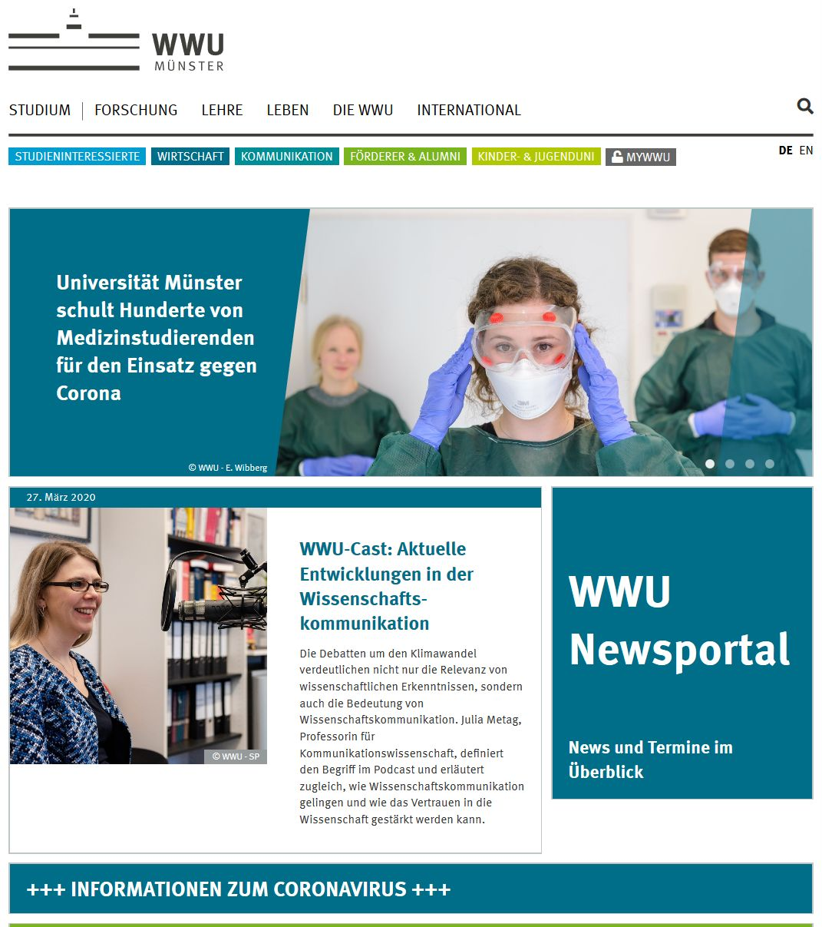

# Throat swab instead of resting: The University of Münster trains hundreds of medical students for use against corona

# Münster (mfm/tb) - The old plaits have to come off - and sometimes also a beard. Arne Beyer wore his face jewellery for six years already, now he had to sacrifice it. No trace of grief: "There are more important things at the moment", laughs the 23-year-old. He is one of hundreds of students currently being trained by the Medical Faculty of the Westphalian Wilhelms University of Münster (WWU) to help fight the corona pandemic. The campaign, which is unique in Germany, is already bearing fruit: the first students are on duty - in the University Hospital of Münster, but also in other teaching hospitals of the WWU. There they have to wear protective masks - and underneath them no beard fits.

# In mid-March, a circular from the EMU Rectorate also brought the news to the Faculty of Medicine of the University of Münster: in the whole of North Rhine-Westphalia, no teaching at the universities for the time being. On the one hand the suspension of teaching, on the other hand courses of study that could be useful in the face of the greatest social challenge of the last decades and thirdly students who wanted to become active - Dean of Studies Prof. Bernhard Marschall put all three together: He asked "his" approximately 3,000 students of human medicine and dentistry who would like to volunteer and what previous knowledge they could bring to the table. Background: Many future doctors have gained practical experience before or during their studies; their qualifications range up to completed training as nurses, MTA or MFA.

# "The response was overwhelming. So far, more than 1,800 students have registered who want to get involved," says Prof. Marschall happily. Those who have completed their nursing training have been employed directly at the University Hospital, for the others the faculty has created a special further training course. "Building up such a course usually takes up to half a year. We managed it in one week," says Dr. Hendrik Friederichs, who heads the "Studienhospital" at the University of Münster and who, with a small team, set up the "MediCOVID" program. Its goal is to make students fit for the admission and care of corona patients. "Of course we can rely on the previous knowledge of the students. But it would be irresponsible to let them go to hospitals without special additional training".

# MediCOVID consists of a theoretical part, which the students complete at home via a specially set up website. Afterwards they go to a practical training in the "study hospital". Three points are trained there in particular: Hand disinfection, the correct putting on and especially taking off of protective clothing - "Taking off is much more difficult", says Friederichs - and the smear test for the corona test. This is also "less trivial than one might think". For the time being, only students from the fifth semester onwards are accepted into the MediCOVID training course; they have already completed the hygiene training which is obligatory during their studies.

# On March 19, MediCOVID started, only one day later the first students went to the university hospital for support. Volunteers are also already working at the first of about 30 other teaching hospitals of the University of Münster, such as the St. Barbara Clinic in Hamm. "We also have a responsibility for the region", emphasizes Dean of Studies Marschall. Yesterday, Thursday (26.03.), the first 100 students had completed their training. By next Friday there will be 500. "If the number of corona patients grows exponentially, our capacities must grow exponentially," Dr. Friederichs urges. What happens after the 500? "We will decide in the short term and based on the current situation," announces Prof. Marschall. And for a possible continuation, there is also a need for technical clarification: Currently, there are still a good 350 protective masks missing for the training.

# With MediCOVID, the Medical Faculty of the WWU Münster is taking on a pioneering role - and would like to give it up quickly: "The purpose of a university is to generate and disseminate knowledge. We are therefore happy to make our experience from the MediCOVID program available to other universities," explains the Dean of the Faculty, Prof. Frank Ulrich Müller - and is at the same time proud of the student volunteer corps: "We are very touched by this great commitment!

# Mitstreiter

* The project would hardly be possible without the many comrades-in-arms and, above all, could not be realised in this short time.
* Many of the people mentioned below have achieved almost inhuman things:
* - Britta Brouwer: Planning and coordination of the simulation scenes in the study hospital, training courses from 20.03.2020, creation of e-learning tasks
* - Eva Schönefeld: Coordination of you students who have applied for an assignment; conception of the section "self-management
* - Melanie Friederichs: Research and texts for the website, training courses from 30.03.2020
* - Daniel Winzer: Student and tutor of the first hour (19.03.2020), started working in the first MediCOVID team on the COVID 19 station of the UKM
* - Sarah Lauks: Student and tutor of the first hour (19.03.2020), started working in the first MediCOVID team on the COVID 19 station of the UKM
* - Arne Beyer: Student and tutor of the first hour (19.03.2020), started working in the first MediCOVID team on the COVID 19 station of the UKM
* - Luca Kaiser: Student and tutor of the second training course on 20.03.2020, began working in the second MediCOVID team on the COVID 19 ward of the Barbara Clinic in Hamm-Heessen
* - Lina Lobpreis: Student and tutor of the second training course on 20.03.2020, started working in the second MediCOVID team on the COVID 19 ward of the Barbara Clinic in Hamm-Heessen
* - Leon Feldmeyer: Student and tutor of the second training course on 20.03.2020, started working in the second MediCOVID team on the COVID 19 ward of the Barbara Clinic in Hamm-Heessen
* - Peter Pfeiffer: Student, tutor and "observer" of the second training on 20.03.2020, is part of the film team for the tutorials
* - Lukas Derichs: Student, tutor and "observer" of the first training on 19.03.2020, is part of the film team for the tutorials
* - Elisa Alba Schmidt: student, tutor and "observer" of the second training course on 20.03.2020, is part of the film team for the tutorials
* - Jan Rieß: Student, tutor and "observer" of the second training on 20.03.2020, is part of the film team for the tutorials

# Changelog

# - 12.03.2020: Arrangements with the team of the Studienhospital regarding the training of students

# - 13.03.2020: Preliminary talks with the anaesthetist

# - 14.03.2020: Creation of a concept design

# - 15.03.2020: Completion of a first concept draft, available for download

# - 16.03.2020: Revision of the concept, participation of Task Force UKM

# - 17.03.2020: Further revision of the concept, inclusion of the brainstorming of medical colleagues, classification of work areas and groups, consultation with the UKM steering group

# - 18.03.2020: Preparation of the training of the first students, discussions with medical colleagues from the UKM in Anaesthesia, Internal Medicine and Hygiene regarding the structure and the technical orientation of the COVID 19 wards

# - 19.03.2020: Implementation of the first training for students (tutors of the Studienhospital)

# - 20.03.2020: Deployment of the first MediCOVID team on ward 7 East in UKM; implementation of the second training course for students (tutors of the Studienhospital)

# - 21.03.2020: Shooting of podcasts by trained students; in the process, implementation of the third training course for students (tutors of the Studienhospital); recruitment of students for background research and backup for the website www.medicovid.de

# - 22.03.2020: Completion of the website; finalisation of the planning of the training courses with acting scenes; subsequent rejection of this plan due to escalating patient numbers

# - 23.03.2020: Planning of a new practical training and filming with simulation patients; material procurement under increasingly difficult conditions

# - 24.03.2020: Addition of a packing list for use on the stations

# - 25.03.2020: Renaming of the tutorials to "COVideos", addition of practical hints

# - 26.03.2020: Conversion of the source file of the Johns Hopkins University to current format for chapter "The current situation", start of the mass MediCOVID training courses (daily from 08.00 to 20.00), 100th study participant

# - 27.03.2020: Publication of the press release "Throat swab instead of rest: University of Münster trains hundreds of medical students in the fight against corona", addition of picture material on the website

# - 28.03.2020: Update of the current situation, PAUSE (!)

# - 29.03.2020: Update of the current situation, planning of the course concept for students of dentistry, tinkering with replacement respirators (due to extreme delivery difficulties)

# - 30.03.2020: Training with a new supply of respirators (thank you!) after short-term training with replacement masks, press work with WDR television recordings, interviews for major newspapers

# - 31.03.2020: Addition of current data on mortality in Germany with update of the current situation, parts of the COVideo "First Steps" in "First Steps" and "Introduction" - the COVideos have now been watched more than 5,000 times!

# - • …

# Impressum

-

Referenzen

1. Kluge S, Janssens U, Welte T, Weber-Carstens S, Marx G, Karagiannidis C. Empfehlungen zur intensivmedizinischen therapie von patienten mit covid-19. Medizinische Klinik-Intensivmedizin und Notfallmedizin. 2020;1–3.

2. Wu Z, McGoogan JM. Characteristics of and important lessons from the coronavirus disease 2019 (covid-19) outbreak in china: Summary of a report of 72 314 cases from the chinese center for disease control and prevention. JAMA.

3. Yang X, Yu Y, Xu J, Shu H, Liu H, Wu Y, et al. Clinical course and outcomes of critically ill patients with sars-cov-2 pneumonia in wuhan, china: A single-centered, retrospective, observational study. The Lancet Respiratory Medicine. 2020.

4. Organization WH, others. Clinical management of severe acute respiratory infection when novel coronavirus (‎‎‎ nCoV)‎‎‎ infection is suspected: Interim guidance, 25 january 2020. World Health Organization; 2020.

5. Chan JF-W, Yuan S, Kok K-H, To KK-W, Chu H, Yang J, et al. A familial cluster of pneumonia associated with the 2019 novel coronavirus indicating person-to-person transmission: A study of a family cluster. The Lancet. 2020.

6. Holshue ML, DeBolt C, Lindquist S, Lofy KH, Wiesman J, Bruce H, et al. First case of 2019 novel coronavirus in the united states. New England Journal of Medicine. 2020.

7. Kupferschmidt K. Study claiming new coronavirus can be transmitted by people without symptoms was flawed. Science. 2020.

8. Organization WH, others. Novel coronavirus ( 2019-nCoV): Situation report, 12. 2020.

9. Li Q, Guan X, Wu P, Wang X, Zhou L, Tong Y, et al. Early transmission dynamics in wuhan, china, of novel coronavirus–infected pneumonia. New England Journal of Medicine. 2020.

10. Organization WH, others. Report of the who-china joint mission on coronavirus disease 2019 (covid-19). Available on-line: https://www who int/docs/default-source/coronaviruse/who-china-joint-mission-on-covid-19-final-report pdf. 2020.

11. Kompetenz SA der, others. Hinweise zu erkennung, diagnostik und therapie von patienten mit covid-19. 2020.

12. Team TNCPERE. The epidemiological characteristics of an outbreak of 2019 novel coronavirus diseases (covid-19) — china, 2020. China CDC Weekly. 2020;2:113. <http://weekly.chinacdc.cn//article/id/e53946e2-c6c4-41e9-9a9b-fea8db1a8f51>.

13. Berking M. Training emotionaler kompetenzen. 2017.